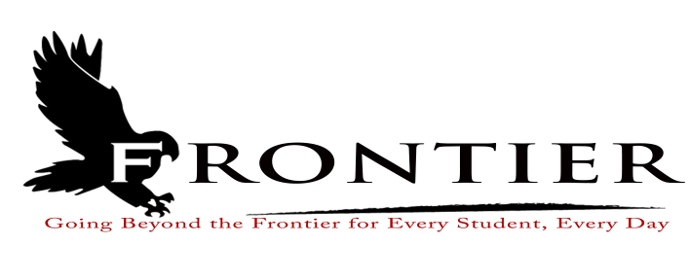

**Frontier School Corporation Trustees, Regular School Board Meeting Agenda**

**Monday, October 28, 2024, 7:00pm**

**Location: Frontier Elementary School Library, 811 Railroad Street, Brookston, IN 47923**

1. Call Meeting to Order
2. Approval of Agenda

2.1-Additions or deletions to agenda

2.2-Approval of agenda

3. Approval of Minutes

3.1-August 19, 2024 Regular School Board Meeting

4. Treasurer’s Report

4.1-September 30, 2024 Fund Report

4.2-September 30, 2024 Appropriation Report

4.3-September 30, 2024 Revenue Report

4.4-September 30, 2024 Bank Reconciliation Report

4.5-September 30, 2024 Bond Reports

4.6-September 30, 2024 Transfer Report

5. Approval of Claims

5.1-October 28, 2024 Claims

6. Reports from Principals & Directors

6.1-Technology-Mr. T.J. McFadden

6.2-Frontier Elementary-Mrs. Jillian Layton

6.3-Frontier Jr.-Sr. High School-Mr. Jeff Hettinger

6.4-Athletics-Mr. Mark Gretencord

6.5-Guidance-Mrs. Kathy Bassett

6.6-Transportation-Mrs. April Hall

6.7-Maintenance-Mr. Chris Peterson

6.8-School Safety-Mr. Jim Bolen

6.9-Superintendent-Mr. Dan Sichting

7. Comments from Public on Agenda Items (three minutes per speaker, 30 minutes total)

8. Budget/Financial

8.1-October FY 2025 Tuition Support Distribution

8.2-Ordinance or Resolution for 2025 Appropriation and Tax Rates

8.3- Resolution for 2025 Budget Authorization of Reductions

8.4-Resolution to Issue Tax Warrant

8.5-Emergent E3 Application and Services Desktop and Mobile Apps as well as onboarding and

Set-Up

8.6-Frontier Jr.-Sr. High School Walk-In Freezer Coolant System Upgrade

8.7-Approval of Chromebook Purchase

9. Personnel:

9.1-Resignations

9.1.1-Mrs. Shyann Burris-Frontier Elementary School Kitchen Assistant/Cashier

9.1.2-Mrs. Brenda Harrison-Frontier Elementary Day Custodian

9.1.3-Mrs. Deb Lucas-Frontier School Corporation Part-Time Bus Aide

9.2-Hires

9.2.1-Mrs. Chelcie Moss-Frontier Elementary Kitchen Assistant/Cashier

9.2.2-Ms. Lisa Fuller-Frontier Elementary School Day Custodian

9.3-2023-2025 Agreement with the Frontier Classroom Teachers Association and the Frontier

School Corporation

9.4-1% Base Salary Increase for Non-Certified Employees, Bus Drivers, and Administrators

9.5-Stipend for Non-Certified Employees, Bus Drivers, and Administrators

9.6-2024-2025 Extra-Curricular Appointments

9.6.1-Mrs. Stephanie Fischer-2024-2025 Jr.-Sr. High School Battle of the Books (Co-Sponsor)

9.6.2-Mrs. Shyann McMillan-2024-2025 Jr.-Sr. High School Battle of the Books (Co-Sponsor)

9.7-2024-2025 Mentors

9.7.1-Mrs. Melissa Culver-Pekny-Mentor for Mr. James Hartman

9.8-Approve Full-Time Status for Frontier School Corporation Bus Aide

10. Field Trips

10.1-Frontier Jr.-Sr. High School FFA (Overnight and Out-of-State)

11. Other Business

11.1-Frontier Jr.-Sr. High School 2024-2025 School Improvement Plan

11.2-School Board Policies, 1st Reading

11.2.1-Policy 1130-Conflict of Interest

11.2.2-Policy 3113-Conflict of Interest

11.2.3-Policy 4113-Conflict of Interest

11.2.4-Policy 6110-Grant Funds

11.2.5-Policy 6111-Internal Control Standards and Procedures

11.2.6-Policy 6112-Cash Management of Grants

11.2.7-Policy 6114-Cost Principles-Spending Federal Grants

11.2.8-Policy 6325-Procurement Federal Grants/Funds

11.2.9-Policy 6550-Travel Payment and Reimbursement/Relocation Costs

11.2.10-Policy 7310-Disposition of Surplus Property

11.2.11-Policy 7450-Property Inventory

12. Comments from the Public (capped at three minutes per speaker, for 30 minutes total). Please

refrain from repeating comments already made by previous speakers.

13. Adjournment

Next Regular Scheduled Board Meeting- Monday, November 18, 2024 at Frontier Jr.-Sr. High

School, One Falcon Driver, Chalmers, Indiana 47929. This meeting is fully accessible. Any person wanting additional accommodations should contact the Frontier School Corporation Superintendent’s Office at (219) 984-5009.