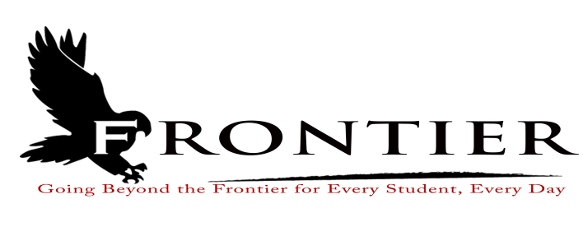

**Frontier School Corporation Trustees, Regular School Board Meeting Agenda**

**Monday, September 16, 2024, 7:00pm**

**Location: Frontier Jr/Sr High School Library, 1 Falcon Drive, Chalmers, IN 47929**

**Revised**

1. Call Meeting to Order
2. Approval of Agenda

2.1-Additions or deletions to agenda

2.2-Approval of agenda

3. Approval of Minutes

3.1-August 19, 2024 Regular School Board Meeting

4. Treasurer’s Report

4.1-August 31, 2024 Fund Report

4.2-August 31, 2024 Appropriation Report

4.3-August 31, 2024 Revenue Report

4.4-August 31, 2024 Bank Reconciliation Report

4.5-August 31, 2024 Bond Reports

4.6-August 31, 2024 Transfer Report

5. Approval of Claims

5.1-September 16, 2024 Claims

6. Reports from Principals & Directors

6.1-Technology-Mr. T.J. McFadden

6.2-Frontier Elementary-Mrs. Jillian Layton

6.3-Frontier Jr.-Sr. High School-Mr. Jeff Hettinger

6.4-Athletics-Mr. Mark Gretencord

6.5-Guidance-Mrs. Kathy Bassett

6.6-Transportation-Mrs. April Hall

6.7-Maintenance-Mr. Chris Peterson

6.8-School Safety-Mr. Jim Bolen

6.9-Superintendent-Mr. Dan Sichting

7. Comments from Public on Agenda Items (three minutes per speaker, 30 minutes total)

8. Budget/Financial

8.1-September FY 2025 Tuition Support Distribution

8.2-Hearing on 2025 School Bus Replacement Plan (Public Comment Period)

8.3-2025 School Bus Replacement Plan Resolution

8.4-Hearing on 2025 Capital Projects Plan (Public Comment Period)

8.5-2025 Capital Projects Plan Resolution

8.6-Hearing on 2025 Frontier School Corporation Budget (Public Comment Period)

8.7-2023-2024 Frontier School Annual Financial Report

8.8-Award Certificates Of Deposit-August Renewal to Fountain Trust

8.9-Award Certificate of Deposit-September Renewal to Fountain Trust

8.10-Boyce Systems Annual Subscription for Financial, Payroll, and Personnel Modules

8.11-Replacement Purchase of School Resource Vehicle

8.12-2025 Bus Purchase

9. Personnel:

9.1-Resignations

9.1.1-Mrs. Cathy Clevenger-Frontier School Corporation Part-Time School Bus Aide

9.1.2-Mr. David Addison-Frontier Jr.-Sr. High School Chemistry Teacher

9.2-Hires

9.2.1-Ms. Destiny Bowsman-Frontier School Corporation School Part-Time Bus Aide

9.2.2-Mr. James Hartman-Frontier Jr.-Sr. High School Chemistry Teacher

9.2.2-Mrs. Alison Gray-Frontier Jr.-Sr. High School Kitchen Assistant/Dish Room Attendant

9.2.3-Mrs. Erica Wharf-Frontier Elementary Part-Time Instructional Assistant

9.3-Approve Mrs. Allison Judy Pay Differential for Special Education

9.4-Approve Wage Increase for Mrs. April Hall, Frontier School Corporation Transportation

Director

9.5-2024-2025 Extracurricular Appointments

9.5.1-Mrs. Stephanie Fischer-Battle of Books 7th-8th Co-Sponsor

9.5.2-Mrs. Meredith Helderle-Frontier Jr.-Sr. High School Girls Varsity Basketball Assistant

9.5.3-Mrs. Cretia Jensen-Battle of Books 4th-6th Grade Sponsor

9.5.4-Mrs. Shyann McMillan-Battle of the Books 7th-8th Co-Sponsor

9.5.5-Mrs. Sharon Miller-Frontier Jr.-Sr. High School Girls Varsity Basketball

9.5.6-Ms. Desiree Meyers-Frontier Elementary Student Council Co-Sponsor

9.5.7-Miss Campbell Pekny-Frontier Jr.-Sr. High School Varsity Wrestling Volunteer Assistant

9.5.8-Mr. Griffin Prickell-Frontier Jr.-Sr. High School Varsity Wrestling Volunteer Assistant and Junior High Wrestling Coach

9.5.9-Mr. Tyler Pruitt-Frontier Jr.-Sr. High School Varsity Wrestling Assistant Coach

9.5.10-Mrs. Chyanne Ray-Frontier Elementary Student Council Co-Sponsor

9.5.11-Mr. J.T. Veach-Frontier Jr.-Sr. High School Junior High Wrestling Coach

9.6-2024-2025 Mentors

9.6.1-Mrs. Kelly Knochel-Mentor for Dr. Michael Pratt

9.7-Collective Bargaining Hearing

9.8-Adjust Frontier School Corporation Mini-Bus Driver Hourly Rate

9.9-Adjust Frontier School Corporation Part-Time Bus Aide Hourly Rate

9.10-Adjust Frontier School Corporation Yellow Bus Driver Daily Rate

9.11-Adjust Frontier School Corporation Substitute Bus Aide Hourly Rate

10. Field Trips

11. Other Business

11.1-Donations

11.2-Indiana Department of Transportation Purchase Agreement for One-Half of Acre at

Frontier Elementary School

11.3-2024-2025 Frontier Elementary School Improvement Plan

12. Comments from the Public (capped at three minutes per speaker, for 30 minutes total). Please

refrain from repeating comments already made by previous speakers.

13. Adjournment

Next Regular Scheduled Board Meeting- Monday, October 28, 2024 at Frontier Elementary

School, 811 Railroad Street, Brookston, Indiana 47923. This meeting is fully accessible. Any person wanting additional accommodations should contact the Frontier School Corporation Superintendent’s Office at (219) 984-5009.