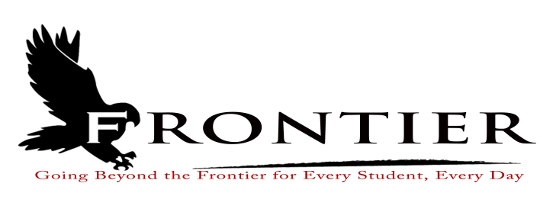
Frontier School Corporation Trustees
Regular School Board Meeting Agenda
Monday, December 18, 2023
Location: Frontier Elementary School; 811 Railroad Street, Brookston, IN 47923
7:00 P.M.

Notice is hereby given the Frontier School Corporation will meet in Executive Session prior to the school board meeting for the following reason:
(11) To train the School Board members with an outside consultant about the performance of the role of its members as public officials

Revised
- Call Meeting to Order
- Approval of Agenda
2.1-Additions or deletions to agenda
2.2-Approval of agenda
3. Approval of Minutes
3.1-November 20, 2023 Regular Board Meeting
4. Treasurer’s Report
4.1-November 30, 2023 Fund Report
4.2-November 30, 2023 Appropriations Report
4.3-November 30, 2023 Revenue Report
4.4-November 30, 2023 Bank Reconciliation Report
4.5-November 30, 2023 Bond Report
4.6-November 30, 2023 Transfer Report
5. Approval of Claims
5.1-December 18, 2023 Claims
6. Reports from Principals & Directors
6.1-Technology-Mr. T.J. McFadden
6.2-Frontier Elementary-Mrs. Jillian Layton
6.3-Frontier Jr.-Sr. High School-Mr. Jeff Hettinger
6.4-Athletics-Mr. Mark Gretencord
6.5-Guidance-Mrs. Kathy Bassett
6.6-Transportation-Mrs. April Hall
6.7-Maintenance-Mr. Chris Peterson
6.8-School Safety-Jim Bolen
6.9-Superintendent-Mr. Dan Sichting
7. Comments from Public on Agenda Items (Capped at thirty minutes total and three minutes per
speaker)

8. Budget/Financial
8.1-December FY 2024 Tuition Support Distribution
8.2-December 2023 Property Tax Settlement
8.3-December 2023 Commercial Vehicle Excise Tax, Excise Tax, and Financial Institutions Tax
Settlement
8.4-Rescind 2024 Budget Form 4 from October 16, 2023
8.5-Comments on Proposed 2024 Operations Fund Property Tax Levy
8.6-2024 Updated Ordinance or Resolution for Appropriations and Tax Rates
8.7-Toshiba Copier Lease for Frontier School Corporation Superintendent’s Office
8.8-2023 Teacher Appreciation Grant Stipends
8.9-Green Light Lawn Care Snow Removal Quote
8.10-Indiana School Boards Association Superintendent Search Agreement
8.11-Hi-Com payment for Door Access System
8.12-2024 15 Passenger Mini-Bus Quotes
9. Personnel
9.1-Resignations
9.1.1-Rita Floyd- Frontier Elementary School Kitchen Assistant
9.1.2-Tyler Pruitt-Frontier Jr.-Sr. High School Weight Room Supervisor
9.2-Superintendent Intent to Retire
9.3-Hires
9.3.1-Hire Frontier School Corporation Assistant Payroll Clerk/Assistant Treasurer
9.3.2-Hire Frontier Elementary Day Custodian
9.3.3-Hire Temporary Language Arts/Math Interventionist
9.3.4-Hire Frontier Elementary Kitchen Cashier and Kitchen Assistant
9.4-Hire Temporary Long-Term Substitute Teacher for Frontier Jr.-Sr. High School Teacher
9.5-Maternity Leave for Frontier Elementary STEM Teacher
9.6-2023-2024 Extracurricular Recommendations
9.6.1-Frontier Jr.-Sr. High School Baseball Coach
9.6.2-Frontier Jr.-Sr. High School Softball Coach
9.6.3-Frontier Jr.-Sr. High School Girls Varsity Assistant Track Coach
9.6.4-Frontier Jr.-Sr. High School 7th & 8th Boys Track Head Coach
9.6.5-Frontier Jr.-Sr. High School Volunteer Wrestling Coach
9.6.6-Frontier Jr.-Sr. High School Boys Track Varsity Assistant Coach
9.7-Hire Temporary English/Language Arts/Math Interventionist at Frontier Jr.-Sr. High School
9.8-Food Service Director Consultant Compensation
10. Field Trips
11. Other Business
11.1-December 2023 Donations
11.2-Frontier Elementary Updated Extracurricular Account Descriptions
12. Comments from the Public (Comments should be no longer than three (3) minutes per speaker.
Time is capped at thirty minutes, and please refrain from repeating comments already made by
previous speakers.)
13. Adjournment

Next Regular Scheduled Board Meeting-Monday, January 15, 2024 at Frontier Jr.-Sr. High
School, 1 Falcon Drive, Chalmers, IN 47929

This meeting is fully accessible. Any person wanting additional accommodations should contact
the Frontier School Corporation Superintendent’s Office at (219) 984-5009.

