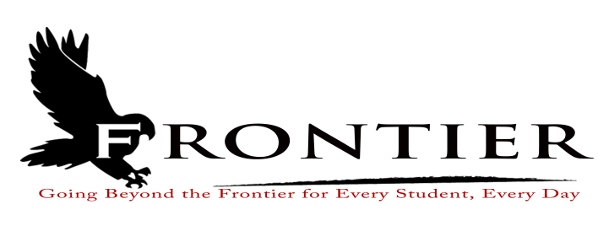
Frontier School Corporation Trustees
Regular School Board Meeting Agenda
Monday, March 18, 2024
Location: Frontier Jr.-Sr. High School Library, 1 Falcon Drive, Chalmers, IN 47929
7:00 P.M.

Revised
- Call Meeting to Order
- Approval of Agenda
2.1-Additions or deletions to agenda
2.2-Approval of agenda
3. Approval of Minutes
3.1-February 26, 2024 Regular School Board Meeting
4. Treasurer’s Report
4.1-February 29, 2024 Fund Report
4.2-February 29, 2024 Appropriations Report
4.3-February 29, 2024 Revenue Report
4.4-February 29, 2024 Bank Reconciliation Report
4.5-February 29, 2024 Bond Report
4.6-February 29, 2024 Transfer Report
5. Approval of Claims
5.1-March 18, 2024 Claims
6. Reports from Principals & Directors
6.1-Technology-Mr. T.J. McFadden
6.2-Frontier Elementary-Mrs. Jillian Layton
6.3-Frontier Jr.-Sr. High School-Mr. Jeff Hettinger
6.4-Athletics-Mr. Mark Gretencord
6.5-Guidance-Mrs. Kathy Bassett
6.6-Transportation-Mrs. April Hall
6.7-Maintenance-Mr. Chris Peterson
6.8-School Safety-Mr. Jim Bolen
6.9-Superintendent-Mr. Dan Sichting
7. Comments from Public on Agenda Items (Capped at thirty minutes total and three minutes per
speaker)
8. Budget/Financial
8.1-March FY 2024 Tuition Support Distribution
8.2-Brookston Gym Painting Quotes
8.3-Frontier Elementary School Intercom Quotes
8.4-Frontier Elementary School Fire Alarm Panel Quotes
9. Personnel
9.1-Resignations
9.1.1-Mr. Derek Dean-Frontier Jr.-Sr. High School Physical Education Teacher
9.2-Hires
9.2.1-Frontier Jr.-Sr High School Kitchen Assistant/Dish Room Attendant
9.2.2-Frontier School Corporation Summer Maintenance Assistant
9.2.3-Frontier School Corporation Minibus Substitute Driver
9.3-2023-2024 Extracurricular Appointments
9.3.1-Frontier Jr.-Sr. High School Volunteer Assistant Golf Coach
9.3.2-Frontier Jr.-Sr. High School Volunteer Assistant Golf Coach
9.4-Frontier Elementary Cafeteria Manager Hourly Wage Increase
9.5-Hire Frontier Elementary School 1st Grade Maternity Leave Long-Term Substitute Teacher
9.6-Frontier Jr.-Sr. High School Instructional Assistant Hourly Wage for CPR Training
10. Field Trips
10.1-Frontier Jr.-Sr. High School Health Occupations Students of America (Overnight)
11. Other Business
11.1-2024-2025 Frontier School Corporation Grade Level Transfer Numbers
11.2-2024-2025 Frontier Elementary Student Handbook
11.3-A.I.A Frontier Elementary School Danco Roofing Contract
11.4-Authorization to Sign Agreements for Special Education Alternative Services and Private
Residential School Placements
11.5-2024 Landscape and Lawncare Quotes
11.6-2025-2026 School Calendar Survey Results
11.6.1-Parents
11.6.2-Students
12. Comments from the Public (Comments should be no longer than three (3) minutes per speaker.
Time is capped at thirty minutes, and please refrain from repeating comments already made by
previous speakers.)
13. Adjournment

Next Regular Scheduled Board Meeting-Monday, April 15, 2024 at Frontier Elementary
School, 811 Railroad Street, Brookstn, IN 47923

This meeting is fully accessible. Any person wanting additional accommodations should contact
the Frontier School Corporation Superintendent’s Office at (219) 984-5009.

