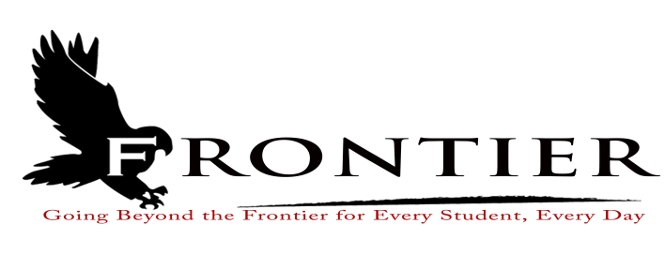
Frontier School Corporation Trustees
Regular School Board Meeting Agenda
Monday, February 26, 2024
Location: Frontier Elementary School Library, 811 Railroad Street, Brookston, IN 47923
7:00 P.M.

Revised
- Call Meeting to Order
- Approval of Agenda
2.1-Additions or deletions to agenda
2.2-Approval of agenda
3. Approval of Minutes
3.1-January 15, 2024 Reorganization Meeting
3.2 -January 15, 2024 Board of Finance Meeting
3.3-January 15, 2024 Regular Board Meeting
4. Treasurer’s Report
4.1-January 31, 2024 Fund Report
4.2-January 31, 2024 Appropriations Report
4.3-January 31, 2024 Revenue Report
4.4-January 31, 2024 Bank Reconciliation Report
4.5-January 31, 2024 Bond Report
4.6-January 31, 2024 Transfer Report
4.7-2023 Year End Fund Report
4.8-2023 Year End Appropriation
4.9-2023 Year End Revenue Report
4.10-2023 Year End Appropriation Transfers
5. Approval of Claims
5.1-February 26, 2024 Claims
6. Reports from Principals & Directors
6.1-Technology-Mr. T.J. McFadden
6.2-Frontier Elementary-Mrs. Jillian Layton
6.3-Frontier Jr.-Sr. High School-Mr. Jeff Hettinger
6.4-Athletics-Mr. Mark Gretencord
6.5-Guidance-Mrs. Kathy Bassett
6.6-Transportation-Mrs. April Hall
6.7-Food Service-Steven Boulanger
6.8-Maintenance-Mr. Chris Peterson
6.9-School Safety-Jim Bolen
6.10-Superintendent-Mr. Dan Sichting
7. Comments from Public on Agenda Items (Capped at thirty minutes total and three minutes per
speaker)
8. Budget/Financial
8.1-February FY 2024 Tuition Support Distribution
8.2-Early Literacy Achievement Grant Resolution
8.3-Resolution for Transfer from Pension Debt Fund to Debt Service Fund
8.4-Resolution for Transfer from Operations Fund to Rainy Day Fund
8.5-Engagement Letter/Fee Agreement with Lewis-Kappes Law Firm
8.6- Resolution Electing to Join or Enlarge the Public Employees’ Retirement Fund as
administered by the Indiana Public Retirement System
8.7-2024 Bonds Repayment Length and Debt Service Tax Rate
8.8-Approval of 1003 Waiver
8.9-Review of Frontier School Corporation Investment Policy
9. Personnel
9.1-Resignations
9.1.1-Miss Chelcie Moss-Frontier Elementary Cafeteria Cashier/Kitchen Assistant
9.1.2-Mrs. Stacy Snoble-Frontier Jr.-Sr. High School Chemistry Teacher
9.1.3-Mr. Mark Wessel-Yellow Bus Driver
9.2-Hires
9.2.1-Hire Frontier School Corporation Minibus Instructional Assistant
9.2.2-Hire Frontier School Corporation Yellow Bus Driver
9.2.3-Hire Frontier Jr.-Sr. High School Homebound Instructor
9.2.4-Hire Frontier Elementary Cafeteria Cashier/Kitchen Assistant
9.3-2023-2024 Extracurricular Appointments
9.3.1-Mr. Trevor Benakovich-Baseball 1st Assistant Coach
9.3.2-Mr. Dan Layton-Baseball Volunteer Assistant Coach
9.3.3-Mr. Kyle Sorenson-Baseball Volunteer Assistant Coach
9.3.4-Mr. Kaleb Wagner-Baseball 2nd Assistant Coach
9.4-Frontier Elementary Custodian Hourly Wage Increase
9.5-Frontier Elementary School 1st Grade Teacher Maternity Leave
9.6-Frontier Elementary Summer School 2024 Hires
9.6.1-Mrs. Gretchen Innocent-Kindergarten Boot Camp Teacher
9.6.2-Ms. Stefanie Greer-Kindergarten Boot Camp Instructional Assistant
9.6.3-Mrs. Joy Henson-Phonics Boot Camp Instructional Assistant
9.6.4-Mrs. Jill Woods-Phonics Boot Camp Teacher
9.7-Approve Frontier Elementary long term STEM substitute
10. Field Trips
11. Other Business
11.1-February 2024 Donations
11.2-Quality Roofing Services Bid Removal Request
11.3-Award Roof Replacement for Frontier Elementary School to Danco Roofing Services
11.4-Award Roof Replacement for Frontier Jr.-Sr. High School to Superior Roofing Services, Inc.
11.5-2024 Payout of Helen Higgins Scholarship Trust
11.6-Approve Early Dismissal for April 8, 2024 for Solar Eclipse
11.7-Revised 2023-2024 Frontier School Corporation Dyslexia Plan and Protocols
12. Comments from the Public (Comments should be no longer than three (3) minutes per speaker.
Time is capped at thirty minutes, and please refrain from repeating comments already made by
previous speakers.)
13. Adjournment

Next Regular Scheduled Board Meeting-Monday, March 18, 2024 at Frontier Jr/Sr High
School, 1 Falcon Drive, Chalmers, IN 47929

This meeting is fully accessible. Any person wanting additional accommodations should contact
the Frontier School Corporation Superintendent’s Office at (219) 984-5009.

