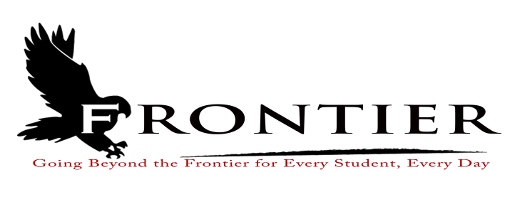
Frontier School Corporation Trustees
November Special School Board Meeting Agenda
Wednesday, November 8, 2023
Location: Frontier Jr.-Sr. High School; One Falcon Drive, Chalmers, IN 47929
7:00 P.M.

Revised
- Meeting to Order
- Approval of Agenda
2.1-Additions or deletions to agenda
2.2-Approval of Agenda
- Comments from the Public on Agenda Items (Capped at thirty minutes total and three minutes per speaker)
- Budget/Financial
4.1-Approval of 2023-2025 Agreement between Frontier School Corporation and the Frontier
Classroom Teachers Association
4.2-Approve Non-Certified Employee Hourly Wage Increase
4.3-2024 Non-Certified Employee Health Insurance Contributions
4.4-Approve of 2023-2024 Administrator Salary Increases
4.5-Approve 2024 Administrative Health Savings Account Deposits
4.6-Approve Quote for Replacement of Frontier Jr.-Sr. High School Water Heater
- Personnel
4.1-Hire Frontier Elementary Day Time Custodian
- Comments from the Public on Agenda Items (Capped at thirty minutes total and three minutes per speaker)
- Adjournment

Next Regular Scheduled Board Meeting-Monday, November 20, 2023 at Frontier Jr.-Sr. High
School Library, One Falcon Drive, Chalmers, IN 47929

This meeting is fully accessible. Any person wanting additional accommodations should contact
the Frontier School Corporation Superintendent’s Office at (219) 984-5009.

Notice is hereby given the Frontier School Corporation School Board will meet in Executive
Session immediately following adjournment. The purpose of the Executive Session is:

To Discuss job performance evaluation of individual employees. This subdivision doesn’t
apply to a discussion of an employee’s salary, compensation, or benefits during a budget
process.

