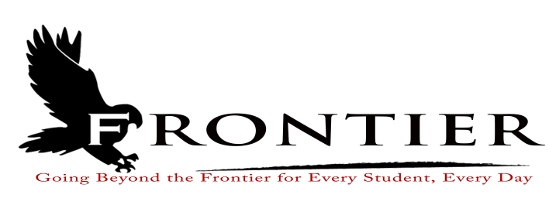

Frontier School Corporation
Monday, October 16, 2023
6:00 P.M.
Frontier Elementary School Conference Room

Notice is hereby given the Frontier School Corporation School Board will meet in Executive Session for the following reason:

IC 5-14-1.5-6.1 (11) To train school board members with an outside consultant about the performance of role of the members as public officials

Frontier School Corporation Trustees
September Regular School Board Meeting Agenda
Monday, October 16, 2023
7:00 P.M.
Location: Frontier Elementary School, 811 Railroad Street, Brookston, IN 47923

- Call Meeting to Order
- Approval of Agenda
2.1-Additions or deletions to agenda
2.2-Approval of agenda
3. Approval of Minutes
3.1-September 18, 2023 Collective Bargaining Hearing
3.2-September 18, 2023 Project Hearing
3.4-September 18, 2023 Budget Hearing
3.4-September 18, 2023 Regular Board Meeting
4. Treasurer’s Report
4.1-September 30, 2023 Fund Report
4.2-September 30, 2023 Appropriations Report
4.3-September 30, 2023 Revenue Report
4.4-September 30, 2023 Bank Reconciliation Report
4.5-September 30, 2023 Bond Report
4.6-September 30, 2023 Transfer Report
5. Approval of Claims
5.1-October 16, 2023 Claims
6. Reports from Principals, Directors
6.1-Technology-Mr.T.J. McFadden
6.2-Frontier Elementary-Mrs. Jillian Layton
6.3-Frontier Jr.-Sr. High School-Mr. Jeff Hettinger
6.4-Athletics-Mr. Mark Gretencord
6.5-Guidance-Mrs. Kathy Bassett
6.6-Transportation-Mrs. April Hall
6.7-Maintenance-Mr. Chris Peterson
6.8-School Safety-Jim Bolen
6.9-Superintendent-Mr. Dan Sichting
7. Comments from Public on Agenda Items (Capped at thirty minutes total and three minutes per
speaker)
8. Budget/Financial
8.1-October FY 2024 Tuition Support Distribution
8.2-Ordinance or Resolution for 2024 Appropriation and Tax Rates
8.3- Resolution for 2024 Budget Authorization of Reductions
8.4-Resolution to Issue Tax Warrant
8.5-Wabash Valley Education Center Food Service Consultant Contract
8.6-Lafayette Glass Bullet Resistant Window Quote-Frontier Elementary
8.7-2023-2024 AdTec Erate Consulting Agreement
8.8-Baker Tilly Municipal Advisors Engagement Letter for Debt Issuance and Continuing
Disclosure
8.9-Award School Safety Grant Door Access Quote
8.10-Resolution approving Form of Seventh Amendment to Lease
8.11-Resolution reapproving Building Corporation
9. Personnel
9.1-Resignations
9.1-Resignation of Frontier School Corporation Yellow Bus Driver
9.2-Hires
9.2.1-Hire Frontier School Corporation Mini-Bus Driver effective September 18, 2023.
9.2.2-Hire Frontier School Corporation Yellow Bus Driver effective October 30, 2023
9.3-2023-2024 Extracurricular Recommendations
9.3.1-Mr. Tyler Pruitt-Frontier Jr.-Sr. High School Varsity Wrestling Assistant Coach
9.3.2-Mr. Tyler Pruitt-Frontier Jr.-Sr. High School Junior High Wrestling Assistant Coach
9.3.3-Mr. Kyle Marlatt-Frontier Girls Basketball 6th Grade Head Coach
9.3.4-Mr. J.T. Veach-Frontier Jr.-Sr. High School Junior High Wrestling Assistant Coach
10. Field Trips
11. Other Business
11.1-October 2023 Donations
11.2-Frontier Jr.-Sr. High School Improvement Plan
11.3-International Travel Program Update
12. Comments from the Public (Comments should be no longer than three (3) minutes and total time
is capped at thirty minutes, and please refrain from repeating comments already made by earlier speakers)
13. Adjournment

Next Regular Scheduled Board Meeting-Monday, November 20, 2023 at FrontierJr.-Sr. High School, 1 Falcon Drive, Chalmers, IN 47929

This meeting is fully accessible. Any person wanting additional accommodations should contact
the Frontier School Corporation Superintendent’s Office at (219) 984-5009.

