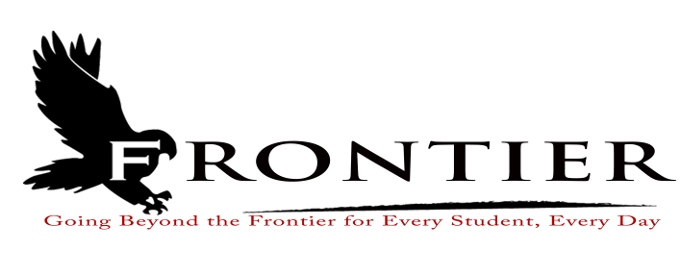
PUBLIC HEARING NOTICE

PUBLIC HEARING OF THE FRONTIER CLASSROOM TEACHERS ASSOCIATION AND THE FRONTIER SCHOOL CORPORATION

The Public Hearing will be held on Monday, September 18, 2023 at Frontier Jr.-Sr. High School Library at One Falcon Drive in Chalmers, Indiana at 6:45 P.M.

Indiana Public testimony will be taken at this hearing pursuant to Indiana Code 20-29-6-1(a) regarding teacher compensation and collective bargaining.

The Public Hearing is hosted jointly by the Frontier Classroom Teachers Association and Frontier School Corporation.

*This meeting is fully accessible. Any person requiring further accommodations should contact the school corporation office at 219-984-5009.

Frontier School Corporation
Collective Bargaining Hearing
Monday, September 18, 2023
Location: Frontier Jr.-Sr. High School Library, One Falcon Drive, Chalmers, IN 47929
6:45 P.M.

The September 18, 2023 Collective Bargaining Hearing will be held at the Frontier Jr.-Sr. High School Library.

- Welcome
- Guidelines for Hearing
- Frontier School Corporation Statement
- Frontier Classroom Teachers Association Statement
- Public Comment
- Closing

This meeting is fully accessible. Patrons requesting additional accommodations should contact the Frontier School Corporation Superintendent’s Office at 219-984-5009.

