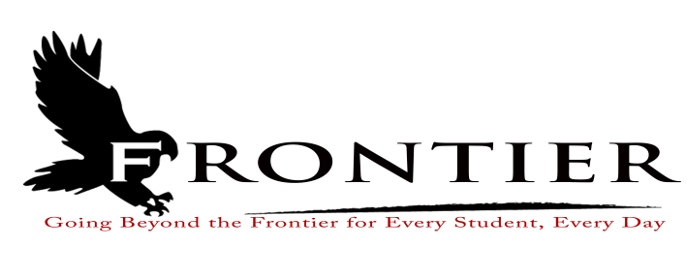

NOTICE OF HEARING

Pursuant to Indiana Code § 20-26-7-37, notice is hereby given that the Board of School Trustees of the Frontier School Corporation will meet at 7:00 p.m. on September 18, 2023, in the library of the Frontier Jr.-Sr. High School, 125 E. Main Street, Chalmers, Indiana, to hold a hearing to discuss and hear objections and support regarding the proposed renovation of and improvements to the Frontier Jr./Sr. High, Frontier Elementary School and Brookston Gym, including site improvements and the purchase of equipment and technology. You are invited to attend and participate in the public hearing.
Dated September 6, 2023.

Laura Bell, Board of School Trustees
Frontier School Corporation

