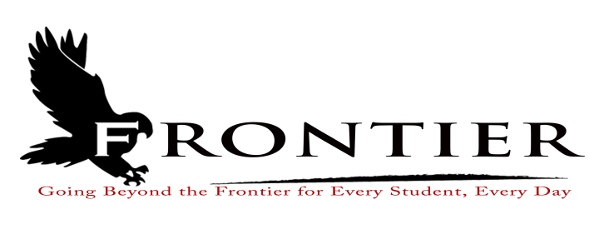
Frontier School Corporation Trustees
July Regular School Board Meeting Agenda
Monday, July 24, 2023
Location: Frontier Jr.-Sr. High School; 1 Falcon Drive, Chalmers, IN 47929
7:00 P.M.

- Call Meeting to Order
- Approval of Agenda
2.1-Additions or deletions to agenda
2.2-Approval of agenda
3. Approval of Minutes
3.1-June 19, 2023 Regular Board Meeting
4. Treasurer’s Report
4.1-June 30, 2023 Fund Report
4.2-June 30, 2023 Appropriations Report
4.3-June 30, 2023 Revenue Report
4.4-June 30, 2023 Bank Reconciliation Report
4.5-June 30, 2023 Bond Report
4.6-June 30, 2023 Transfer Report
5. Approval of Claims
5.1-July 24, 2023 Claims
6. Reports from Principals, Directors
6.1-Technology-Mr. David Hoover
6.2-Frontier Elementary-Mrs.Jillian Layton
6.3-Frontier Jr.-Sr. High School-Mr. Jeff Hettinger
6.4-Athletics-Mr. Mark Gretencord
6.5-Guidance-Mrs. Kathy Bassett
6.6-Transportation-Mrs. April Hall
6.7-Maintenance-Mr. Chris Peterson
6.8-School Safety-Jim Bolen
6.9-Superintendent-Mr. Dan Sichting
7. Comments from Public on Agenda Items (Capped at thirty minutes total and three minutes per
speaker)
8. Budget/Financial
8.1-FY July 2024 Tuition Support Distribution
9. Personnel
9.1-Hire
9.1.1-Miss Elizabeth Spiker-Frontier Jr.-Sr. High School Biology Teacher
9.2-2023-2024 Frontier Jr.-Sr. High School Mentors
9.2.1-Mrs. Melissa Culver-Pekny (Co-Mentor)
9.2.2-Mrs. Melissa Gregorovic
9.2.3-Mrs. JoAnna Mathis (Co-Mentor)
9.2.4-Mr. Maurice Plains (Co-Mentor)
9.2.5-Mrs. Stacy Snoble
9.2.6-Mrs. Amanda Szabella (Co-Mentor)
9.3-2023-2024 Frontier School Corporation Transportation Handbook
9.4-2023-2024 Frontier School Corporation Non-Certified Employee Handbook
9.5-Amend Maintenance Director and Treasurer Wages from Annualized to Hourly
9.6-2023-2024 Extracurricular Recommendation
9.6.1-Mrs.Rechel Funk-Volleyball Co-Head Coach 5th & 6th Grade
9.6.2-Mrs. Anna Mikels-Cross Country Junior High
9.6.3-Mrs.Ashley Rosenbarger-Volleyball Co-Head Coach 5th & 6th Grade
10. Field Trips
11. Other Business
11.1-Amend 2023-2024 Frontier School Corporation School Calendar
11.2-Teacher Discussion Resolution 2023-7-1
11.3-2023-2024 Frontier School Corporation Lunch and Breakfast Prices
11.4-Readopt Board Policy 3220.01-Teacher Appreciation Grants
11.5-Board Policy, 1st Reading
11.5.1-By-Law 0141-Number
11.5.2-By-Law 0142-Election and Eligibility to Serve
11.5.3-By-Law 0142.1-Term
11.5.4-By-Law 0142.2-Oath
11.5.5-By-Law 0142.3-Vacancies and Appointment of Board Members
11.5.6-By-Law 0144.1-Compensation
11.5.7-By-Law 0144.2-Board Member Ethics
11.5.8-By-Law 0152-Officers
11.5.9-By-Law 0164.5-Member Participation in Meetings through Electronic Means of
Communication
11.5.10-By-Law 0167.3-Public Participation at Board Meetings
11.5.11-Policy 1213.01-Staff-Student Relationships
11.5.12-Policy 1425-Nursing Mothers
11.5.13-Policy 1615-Tobacco Use Prevention
11.5.14-Policy 2410-Audio, Video, and Digital Recordings of Meetings
11.5.15-Policy 2461-Recording of IEP Team Meetings/Case Conferences
11.5.16-Policy 2462-Dyslexia Screening and Intervention
11.5.17-Policy 2510-Adoption of Curricular Materials
11.5.18-Policy 3124-Employment Contracts with Professional Employees
11.5.19-Policy 3213.01-Staff-Student Relationships
11.5.20-Policy 3215-Tobacco Use Prevention
11.5.21-Policy 3231-Outside Activities of Staff
11.5.22-Policy 3362.01-Threatening and/or Intimidating Behavior toward Staff Members
11.5.23-Policy 3425-Nursing Mothers
11.5.24-Policy 4120-Employment of Support Staff
11.5.25-Policy 4213.01-Staff-Student Relations
11.5.26-Policy 4215-Tobacco Use Prevention
11.5.27-Policy 4425-Nursing Mothers
11.5.28-Policy 5330-Use of Medication
11.5.29-Policy 5512-Tobacco Use Prevention
11.5.30-Policy 5517-Anti-Harassment
11.5.31-Policy 5517.01-Bullying
11.5.32-Policy 5771-Search and Seizure
11.5.33-Policy 6152-Student Fees and Charges
11.5.34-Policy 6250-Required ADM Counts for the Purpose of State Funding and Verification
For Residency for Membership
11.5.35-Policy 6550-Travel Payment and Reimbursement/Relocation Costs
11.5.36-Policy 6700-Fair Labor Standards Act (FLSA)
11.5.37-Policy 7434-Use of Tobacco on School Property
11.5.38-Policy 7440-Facility Security Program
11.5.39-Policy 7540.02-Web Accessibility, Content, Apps, and Service
11.5.40-Policy 8310-Public Records
11.5.41-Policy 8451-Pediculosis (Head Lice)
11.5.42-Policy 9111-Communications
11.6-Declare Surplus Property for the Purpose of Disposal
12. Comments from the Public (Comments should be no longer than three (3) minutes and total time
is capped at thirty minutes, and please refrain from already made by earlier speakers)
13. Adjournment

Next Regular Scheduled Board Meeting-Monday, August 21, 2023 at Frontier Elementary School
Library, 1 Falcon Drive, Chalmers, IN 47929

This meeting is fully accessible. Any person wanting additional accommodations should contact
the Frontier School Corporation Superintendent’s Office at (219) 984-5009.

