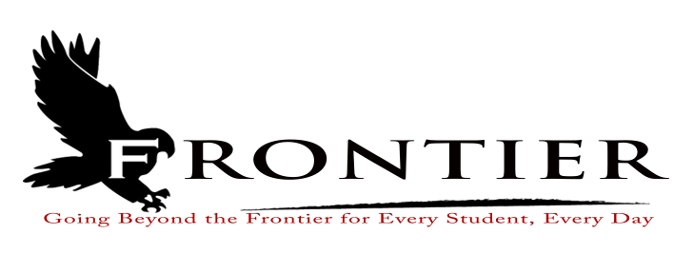
Frontier School Corporation Trustees
May Special School Board Meeting Agenda
Monday, May 22, 2023
Location: Frontier Jr.-Sr. High School; One Falcon Drive Chalmers, IN 47929
6:00 P.M.
- Call Meeting to Order

- Approval of Agenda
2.1-Additions or deletions to agenda
2.2-Approval of agenda

- Personnel
3.1-Hire Frontier Jr.-Sr. High School Long-Term Substitute Teacher
3.2-2023-2024 Extracurricular Recommendation
3.2.1-Mr. Trent Phegley-Boys Varsity Basketball

- Comments from the Public (Comments should be no longer than three (3) minutes, and please refrain from already made by earlier speakers)

- Adjournment

Next Regular Scheduled Board Meeting-Monday, June 19, 2023 at Frontier Elementary School
Library, 811 Railroad Street, Brookston, IN 47923

This meeting is fully accessible. Any person wanting additional accommodations should contact
the Frontier School Corporation Superintendent’s Office at (219) 984-5009.

