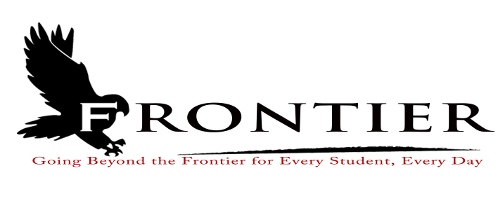
Frontier School Corporation Trustees
May Regular School Board Meeting Agenda
Monday, May 15, 2023
Location: Frontier Jr.-Sr. High School; One Falcon Drive Chalmers, IN 47929
7:00 P.M.
Revised
- Call Meeting to Order
- Approval of Agenda
2.1-Additions or deletions to agenda
2.2-Approval of agenda
- Approval of Minutes
3.1-April 17, 2023 Regular Board Meeting
- Treasurer’s Report
4.1-April 30, 2023 Fund Report
4.2-April 30, 2023 Appropriations Report
4.3-April 30, 2023 Revenue Report
4.4-April 30, 2023 Bank Reconciliation Report
4.5-April 30, 2023 Bond Report
4.6-April 30, 2023 Transfer Report
- Approval of Claims
5.1-May 15, 2023 Claims
- Reports from Principals, Directors
6.1-Technology-Mr. David Hoover
6.2-Frontier Elementary-Mrs.Jillian Layton
6.3-Frontier Jr.-Sr. High School-Mr. Jeff Hettinger
6.4-Athletics-Mr. Mark Gretencord
6.5-Guidance-Mrs. Kathy Bassett
6.6-Transportation-Mrs. April Hall
6.7-Maintenance-Mr. Chris Peterson
6.8-School Safety
6.9-Superintendent-Mr. Dan Sichting
- Budget/Financial
7.1-May FY 2023 Tuition Support Distribution
7.2-Indiana ESC School Food Coop Agreement 2023-2024
7.3-2022-2023 Curricular Materials Reimbursement
7.4-Purdue University IN-Mac Grant
- Personnel
8.1-Resignations
8.1.1-Mrs. Lisa Davis-Frontier School Corporation Math Interventionist
8.1.2-Mr. David Doles-Frontier School Corporation Part-Time Instrumental Music
8.1.3-Mrs. Amy Doles-Frontier School Corporation Part-Time Instrumental Music
8.1.4-Mr. J.D. Hoover-Frontier Jr.-Sr. High School English/Language Arts Teacher
8.2-Hires
8.2.1-Mrs. Lisa Bright-Frontier Jr.-Sr. High School Head Cook
8.2.2-Ms. Charlain Bucher-Frontier Elementary School Custodian
8.2.3-Mrs. Delicia McCoy-Frontier Elementary 6th Grade Teacher
8.2.4-Mr. Donnie Riggs-Frontier School Corporation Instrumental Music Teacher
8.2.5-Mrs. Whitney McFarlin-Frontier Jr.-Sr. High School 7th/8th English/Language Arts
8.3-Approve Frontier Elementary Cafeteria Cashier/Kitchen Assistant 2023-2024 Hours
8.4-Frontier Jr.-Sr. High School Dishwasher/Kitchen Assistant Hourly Pay Rate and Hours
Request
8.5-Frontier Elementary Kindergarten Boot Camp Personnel
8.5.1-Mrs. Gretchen Innocent-July 19, 2023 through August 2, 2023
8.5.2-Mrs. Stephanie Greer-Paraprofessional for Boot Camp
8.6-Frontier Elementary School High Ability Grant Summer Enrichment Sponsors
8.6.1-Mrs. Sherry Banes-Simply Spanish
8.6.2-Mrs. Paula Iunghuhn-Art and Science of Eric Carle
8.6.3-Mrs. Lucretia Jensen-Kitchen Concoctions
8.6.4-Mrs. Cassie Terry-The Great Desert Challenge
8.7-Frontier Elementary Science Curriculum Professional Development
8.8-Approve Frontier Jr.-Sr. High School Mentor
8.8.1-Mrs. Melissa Gregorovic for Mr. Lukas Mosimann
8.9-2023-2024 Extra-Curricular Recommendations
8.9.1-Mrs. Shaina Minnicus-High School Cheerleaders
8.9.2-Miss Danielle Sichting-Girls Varsity Basketball
8.9.3-Mr. J.T. Veach-Wrestling
- Field Trips
9.1-Class of 2023 Field Trip (Out-of-State and Overnight)
- Other Business
10.1-Frontier School Corporation Care Fund Guidelines
10.2-Frontier Elementary Donations
10.3-2023-2024 Frontier Elementary Certified Staff Handbook
10.4-2024-2025 Frontier Jr.-Sr. High School Student Handbook
- Comments from the Public (Comments should be no longer than three (3) minutes, and please refrain from already made by earlier speakers)
- Adjournment

Next Regular Scheduled Board Meeting-Monday, June 19, 2023 at Frontier Elementary School
Library, 811 Railroad Street, Brookston, IN 47923

This meeting is fully accessible. Any person wanting additional accommodations should contact
the Frontier School Corporation Superintendent’s Office at (219) 984-5009.

