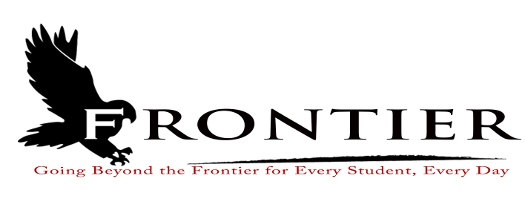
Frontier School Corporation Trustees
February Regular School Board Meeting Agenda
Monday, March 20, 2023
Location: Frontier Jr.-Sr. High School; One Falcon Drive Chalmers, IN 47929
7:00 P.M.
Revised
- Call Meeting to Order
- Approval of Agenda
2.1-Additions or deletions to agenda
2.2-Approval of agenda
- Approval of Minutes
3.1-February 27, 2023 Regular Board Meeting
3.2-March 14, 2023 Public Work Session
- Treasurer’s Report
4.1-February 28, 2023 Fund Report
4.2-February 28, 2023 Appropriations Report
4.3-February 28, 2023 Revenue Report
4.4-February 28, 2023 Bank Reconciliation Report
4.5-February 28, 2023 Bond Report
4.6-February 28, 2023 Transfer Report
- Approval of Claims
5.1-March 20, 2023 Claims
- Reports from Principals, Directors
6.1-Technology-Mr. David Hoover
6.2-Frontier Elementary-Mrs.Jillian Layton
6.3-Frontier Jr.-Sr. High School-Mr. Jeff Hettinger
6.4-Athletics-Mr. Mark Gretencord
6.5-Guidance-Mrs. Kathy Bassett
6.6-Transportation-Mrs. April Hall
6.7-Maintenance-Mr. Chris Peterson
6.8-Superintendent-Mr. Dan Sichting
- Budget/Financial
7.1-March FY 2023 Tuition Support Distribution
7.2-Frontier School Corporation Landscaping and Mowing Quotes
7.3-Outdoor Field Fertilizer, Seeding, and Upkeep Quotes
7.4-School Bus Purchase Amendment
- Personnel
8.1-Termination
8.1.1-Ms. Carrie Ebert-Frontier Elementary Custodian
8.2-Resignation
8.2.1-Mrs. Audra May-Frontier Elementary Physical Education Teacher
8.2.2-Ms. Tamara Nelson-Frontier Jr.-Sr. High School Cafeteria Manager
8.3-Frontier Elementary Dean of Students/Corporation Test Coordinator Maternity Leave
8.4-2023 Frontier Elementary Summer School Appointments
8.4.1-Mrs. Joy Henson-Phonics Bootcamp Instructional Assistant
8.5-Frontier Jr.-Sr. High School Science Summer Professional Development
8.6-Approve Part-Time Summer Maintenance Staff
8.7-Treasurer Overtime Request
8.8-Authority to Advertise Assistant Payroll Clerk/Assistant Treasurer
- Field Trips
- Other Business
10.1-Frontier Elementary 2023-2024 Student Handbook
10.2-Frontier Elementary Science Textbook Adoption
10.3-2023-2024 Frontier Elementary Class Transfer Limits
10.4-2024-2025 Frontier School Corporation School Calendar
10.5-1003 Indiana Department of Education Waiver
10.6-Helen Higgins Trust
- Comments from the Public (Comments should be no longer than three (3) minutes, and please refrain from already made by earlier speakers)
- Adjournment

Next Regular Scheduled Board Meeting-Monday, April 17, 2023 at Frontier Elementary School
Library, 811 Railroad Street, Brookston, IN 47923

This meeting is fully accessible. Any person wanting additional accommodations should contact
the Frontier School Corporation Superintendent’s Office at (219) 984-5009.

