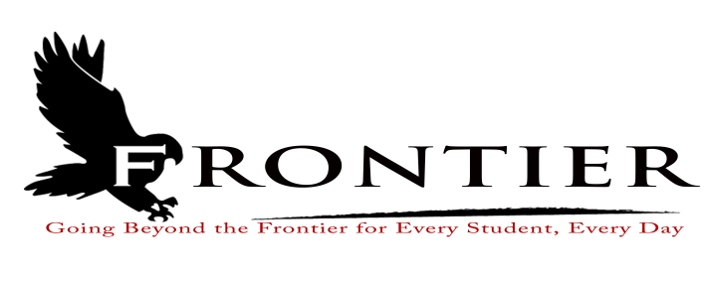
Frontier School Corporation Trustees
September Regular School Board Meeting Agenda
Monday, November 15, 2021
Location: Frontier Jr.-Sr. High School Library, One Falcon Drive, Chalmers, IN 47929
7:00 P.M.

Revised
- Call Meeting to Order
- Approval of Agenda
2.1-Additions or deletions to agenda
2.2-Approval of agenda
- Approval of Minutes
3.1-October 18, 2021 Regular Board Meeting
3.2-November 2, 2021 Tentative Agreement Hearing
3.3-November 8, 2021 Special Board Meeting
- Treasurer’s Report
4.1-October 31, 2021 Fund Report
4.2-October 31, 2021 Appropriations Report
4.3-October 31, 2021 Revenue Report
4.4-October 31, 2021 Bank Reconciliation Report
4.5-October 31, 2021 2020 Bond Report
- Approval of Claims
5.1-November 15, 2021 Claims
- Reports from Principals, Directors
6.1-Technology-Mr. David Hoover
6.2-Frontier Elementary-Mrs.Jillian Layton
6.3-Frontier Jr.-Sr. High School-Mr. Jeff Hettinger
6.4-Athletics-Mr. Troy Burgess
6.5-Transportation-Mrs. April Hall
6.6-Guidance-Mrs. Kathy Bassett
6.7-Maintenance-Mr. Chris Peterson
6.8-Superintendent-Mr. Dan Sichting
- Budget/Financial
7.1-November FY 2022 Tuition Support Distribution
7.2-2022 Powerschool Annual Renewal
7.3-Frontier School Corporation Treasurer Proposal to move Preschool Fund to Education Fund
7.3-Resolution for 2021 Budget Authorization for Reductions
- Personnel
8.1-Resignations
8.1.1-Mr. Peter Johnson-Frontier Jr.-Sr. High School Physical Education effective December 21,
2021
8.1.2-Ms. Allison Thayer-Frontier Jr.-Sr. High School Special Education effective December 21,
2021
8.2-Hires
8.2.1-Deb Lucas-Frontier Elementary School Part-Time Instructional Assistant
8.2.2-Bridgett Raney-Frontier Elementary Instructional Assistant (2nd Semester)
- Field Trips
- Other Business
10.1-November, 2021 Donation
- Other Items for Discussion
- Comments from the Public (Comments should not be longer than five minutes, and please refrain from repeating comments already made by earlier speakers.)
- Adjournment

Next Tentative School Board Meeting: Monday December 20, 2021 at the Frontier Elementary School Library located at 811 Railroad Street, Brookston, IN 47923

This meeting is fully accessible. Any person wanting additional accommodations should contact
the Frontier School Corporation Superintendent’s Office at (219) 984-5009.

