Monday, December 20, 2021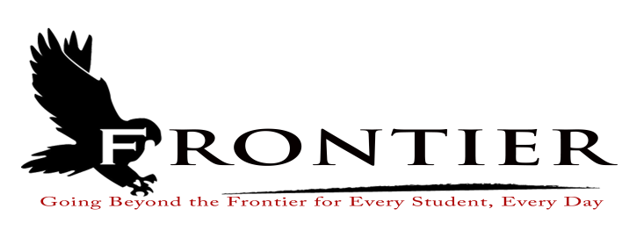
Location: Frontier Elementary School Library, 811 Railroad Street, Brookston, IN 47923
7:00 P.M.

All persons attending or participating in the December 20, 2021 School Board Meeting must comply with the Frontier Elementary Mask Mandate. People attending the meeting must wear a mask or tightly fitting Gaiter.
Revised
- Approval of Minutes
3.1-November 15, 2021 Regular Board Meeting
- Treasurer’s Report
4.1-November 30, 2021 Fund Report
4.2-November 30, 2021 Appropriations Report
4.3-November 30, 2021 Revenue Report
4.4-November 30, 2021 Bank Reconciliation Report
4.5-November 30, 2021 2020 Bond Report
4.6-November 30, 2021 Transfer Report
- Approval of Claims
5.1-December 20, 2021 Claims
- Reports from Principals, Directors
6.1-Technology-Mr. David Hoover
6.2-Frontier Elementary-Mrs.Jillian Layton
6.3-Frontier Jr.-Sr. High School-Mr. Jeff Hettinger
6.4-Athletics-Mr. Troy Burgess
6.5-Transportation-Mrs. April Hall
6.6-Guidance-Mrs. Kathy Bassett
6.7-Maintenance-Mr. Chris Peteron
6.8-Superintendent-Mr. Dan Sichting
- Budget/Financial
7.1-December FY 2022 Tuition Support Distribution
7.2-Frontier School Corporation 2022 Certified Budget Appropriations and Tax Rates
7.3-2021 Operations Fund, Referendum Exempt Operating Post 2009 Fund, and Debt
Fund Total Revenue Analysis
7.4-2022 Frontier School Corporation Resolution for transfer from the Education Fund to the
Operations Fund
7.5-2022 Non-Certified Employee Frontier School Corporation 2022 Contribution to Health
Insurance
7.6-2022 Administrator Health Savings Account Contributions
7.7-Agreement with City Office Janitorial Service
7.8-Authority for Treasurer to pay claims prior to the January 17, 2022 School Board Meeting
- Personnel
8.1-Resignations
8.1.1-Mr. Troy Burgess-Frontier School Corporation Dean of Students/Athletic Director/Varsity
Football Coach
8.1.2-Mr. Edward Hulbert-Frontier School Corporation Custodian
8.1.3-Ms. Rebecca Veach-Frontier Jr.-Sr. High School Part-Time Instructional Assistant
8.1.4-Mr. Jerry Carter-Frontier School Corporation Mini-Bus Driver
8.2-Hires
8.2.1-Mr. Tom Hedde-Frontier Jr.-Sr. High School Special Education (j$52,750)
8.2.2-Mrs. Becky Maddox-Frontier Jr.-Sr. High School Part-Time Instructional Assistant ($11.25
per hour)
8.2.3-Mrs. Belinda Martin-Frontier School Corporation Mini-Bus Driver ($14.50 per hour plus $1.00 per hour differential)
8.2.4-Ms. Jennifer Ousley-Frontier Jr.-Sr High School Physical Education Teacher ($40,250)
8.2.5-Ms. Kristen Reel-Frontier Elementary School Instructional Assistant ($11.25 hourly rate)
8.3-Terminations
8.3.1-Frontier Jr.-Sr. High School Cafeteria Employee
8.3.2-Frontier School Corporation Assistant Maintenance Employee
8.4.-Extra-Curricular Recommendations
8.4.1-Mrs. Alex Hurst-Girl’s 7th Grade Basketball Head Coach
8.4.2-Miss Makayla Schroeder-Frontier Jr.-Sr. High School Volunteer Assistant Cheerleading
Coach
8.4.3-Mrs. Brooke Langley-Frontier Jr.-Sr. High School Girl’s 7th & 8th Grade Girl’s Basketball
Coach
8.5-Hire Interim Frontier Elementary Instructional Assistant (Hourly Rate-$11.25)
8.6-2021 Teacher Appreciation Grant Stipends
8.7-2020-2021 Superintendent Report on Evaluation Results
8.8-Elwood Staffing Temporary Employment Contract
8.9-Express Employment Professional Temporary Employee Agreement
- Field Trips
- Other Business
10.1-Town of Chalmers Facility Use Agreement
10.2-STR-SEG Hardscape Proposal and Cost Estimate
10.3-Ivy Tech Community College Early College Memorandum of Understanding
10.4-December Donations
10.5-Public Hearing 2021-2022 Frontier School Corporation ReOpening Plan
- Other Items for Discussion
- Comments from the Public (Comments should not be longer than five minutes, and please refrain from repeating comments already made by earlier speakers.)
- Adjournment

Reorganization and Board of Finance School Board Meeting: Monday January 10, 2022 at the Frontier Jr.-Sr. High School Library located at One Falcon Drive, Chalmers, IN 47929

This meeting is fully accessible. Any person wanting additional accommodations should contact
the Frontier School Corporation Superintendent’s Office at (219) 984-5009.

