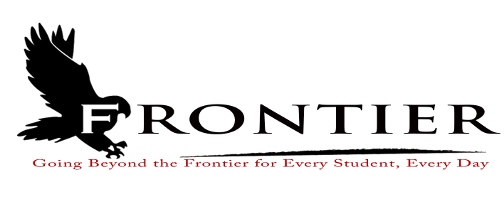
Frontier School Corporation Trustees
April Regular School Board Meeting Agenda
Monday, April 18, 2022
Location: Frontier Elementary School Library, 811 Railroad Street, Brookston, IN 47923
7:00 P.M.

- Call Meeting to Order
- Approval of Agenda
2.1-Additions or deletions to agenda
2.2-Approval of agenda
- Approval of Minutes
3.1-March 28,, 2022 Regular Board Meeting
- Treasurer’s Report
4.1-March 31, 2022 Fund Report
4.2-March 31, 2022 Appropriations Report
4.3-March 31, 2022 Revenue Report
4.4-March 31, 2022 Bank Reconciliation Report
4.5-March 31, 2022 Bond Report
4.6-March 31, 2022 Transfer Report
- Approval of Claims
5.1-April 18, 2022 Claims
- Reports from Principals, Directors
6.1-Technology-Mr. David Hoover
6.2-Frontier Elementary-Mrs.Jillian Layton
6.3-Frontier Jr.-Sr. High School-Mr. Jeff Hettinger
6.4-Athletics-Mr. Raymond Jones
6.5-Transportation-Mrs. April Hall
6.6-Guidance-Mrs. Kathy Bassett
6.7-Maintenance-Mr. Chris Peteron
6.8-Superintendent-Mr. Dan Sichting
- Budget/Financial
7.1-April FY 2022 Tuition Support Distribution
7.2-2022-2026 Math Textbook Adoption
7.3-Resolution to combine 8400 (FHS) and 8401(FES) into 8400 Holding Account
7.4-AdTec Contract Fee E-Rate Agreement for Category 2 Services
- Personnel
8.1-Resignation
8.1.1-Frontier Jr.-Sr. High School Cheerleading Coach
8.2-Hires
8.2.1-Ms.JoAnna Mathis-Frontier School Corporation EL Teacher of Record
8.2.2-Miss Kara Trella-Medical Pathway Teacher (⅝’s teaching position)
8.3-Approve Hourly Rate Increase for Frontier School Corporation Deputy Treasurer
8.4-Increase Technology Assistant Hours from 30 Hours to 37.5 Hours
8.5-Approve Bereavement Leave for Bus Drivers
8.6-Food Service Director Contract
8.7-Frontier Elementary Dean of Students/Corporation Test Coordinator/Instructional Coach Job
Description
8.8-Hire Part-Time Summer Maintenance Assistant
8.9-Hire Frontier School Corporation Summer Enrichment Sponsors
8.10-Hire Frontier School Corporation Bus Driver
- Field Trips
9.1-Frontier Jr.-Sr. High School FCCLA Field Trip (Overnight and Out-of-State)
9.2-Frontier Jr.-Sr. High School BPA Field Trip (Overnight and Out-of-State)
9.3-Frontier Jr.-Sr. High School Girls Varsity and Junior Varsity Basketball Field Trip (Overnight)
- Other Business
10.1-2022-2023 Frontier Elementary Student Handbook Revisions
10.2-2022-2023 Frontier Jr.-Sr. High School Student Handbook Revisions
10.3-2023-2024 Frontier School Corporation Calendar
10.4-2022-2023 Frontier Jr.-Sr. High School Textbook Rental and Class Fee Changes
10.5-Brookston Prairie Township Public Library Board of Trustee Appointment
10.6-2022-2024 Request for Proposal for Property/Casualty, Commercial Automobile, Inland
Marine, Crime, Umbrella Excess, Workmen’s Compensation, Cyber Liability, Commercial
Liability, Employment Practices Liability, Educational Errors & Omissions Liability, and
Security & Law Enforcement Liability and advertisement
- Other Items for Discussion
- Comments from the Public (Comments should not be longer than five minutes, and please refrain from repeating comments already made by earlier speakers.)
- Adjournment

Next Regular Scheduled School Board Meeting-Monday, May 16, 2022 at the Frontier Jr.-Sr. High School Library, One Falcon Drive, Chalmers, IN 47929

This meeting is fully accessible. Any person wanting additional accommodations should contact
the Frontier School Corporation Superintendent’s Office at (219) 984-5009.

